PCL FRIENDS SPRING FUND-RAISER
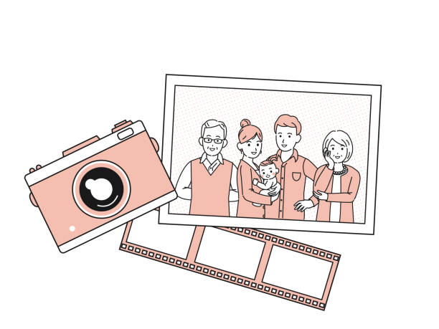
Family/Pet Photo Session

PCL Friends is happy to provide a professional photo session opportunity for up to ten people at our library by kkeenanphotography.com on
Saturday, April 15
Starting at 10:00 AM
$75.00 with profits going to PCL
Includes a zip drive with 15-20 pix plus four 5x7 prints
of the photographer’s choosing.
Book an appointment now: 810.348.3694
A perfect Mother’s Day gift!

PCL Family Photo Appointment for 4/15/23 Call 810.348.3694
A Friends of Peninsula Community Library Fundraiser

PCL Family Photo Appointment for 4/15/23 Call 810.348.3694
A Friends of Peninsula Community Library Fundraiser

PCL Family Photo Appointment for 4/15/23 Call 810.348.3694
A Friends of Peninsula Community Library Fundraiser

PCL Family Photo Appointment for 4/15/23 Call 810.348.3694
A Friends of Peninsula Community Library Fundraiser

PCL Family Photo Appointment for 4/15/23 Call 810.348.3694
A Friends of Peninsula Community Library Fundraiser

